PROJECT ON
“ROCKET LAUNCHING”

PROJECT REPORT SUBMITTED FOR
PARTIAL FULFILMENT OF SUBJECT
INFORMATICS PRACTICES (065)
CLASS XII

UNDER THE GUIDANCE OF
Mrs. A. AJITHA

DONE BY:
M.Varshitha
M.V.Sathwika
P.Pavani


KENDRIYA VIDYALAYA NO.1 TIRUPATI

TABLE OF CONTENTS

S.No | Content | Page Number
1 | Certificate | 4
2 | Acknowledgement | 5
3 | Problem Statement | 6-7
4 | Objective | 8-9
5 | Introduction | 10-13
6 | Hardware & software Requirement | 14-16
7 | Data Collection and Analysis Report | 17-19
8 | System Implementation | 20-34
9 | Output Screenshots | 35-44
10 | Conclusion | 45-46
11 | Bibliography | 47-48

TABLE OF FIGURES

S.No | Figure No. | Description | Page Number
1 | Fig.1 | Main Menu | 36
2 | Fig.2 | Read CSV File | 36
3 | Fig.3 | Data Analysis Menu | 37
4 | Fig.4 | Show Whole Data Frame | 37
5 | Fig.5 | Show Columns | 38
6 | Fig.6 | Show Top Rows | 38
7 | Fig.7 | Show Bottom Rows | 39
8 | Fig.8 | Show Specific Column | 39
9 | Fig.9 | Maximum Rockets Has Launched By the  Country | 40
10 | Fig.10 | Minimum Rockets Has Launched By the  Country | 40
11 | Fig.11 | Maximum Successful Rockets Has Launched By the Country | 41
12 | Fig.12 | Status Of Successful Launched Rockets | 41
13 | Fig.13 | Designation Of Successful Rockets | 42
14 | Fig.14 | Most Used Vehicle For Launching Rockets | 42
15 | Fig. 15 | Data Summary | 43

CERTIFICATE

This is to certify that __________________, student of class XII B has successfully completed the project " Analysis of Rocket Launching" under the guidance of Mrs. A. Ajitha, PGT CS, during the year 2022-23 in partial fulfillment of Informatics Practices (Sub Code: 065) AISSCE Practical Examination.

Signature of Subject In-charge Signature of Principal

Submitted for the External Practical Examination held on _________

Internal Examiner External Examiner

ACKNOWLEDGEMENT

I would like to express my special thanks to our Principal Mrs. P. Anuradha as well as our teacher Mrs. A. Ajitha PGT CS who gave me the golden opportunity to do this wonderful project on the topic Rocket Launching using 'Data Visualization' which also helped me in doing a lot of research and I came to know about so many new things.
Secondly I would also like to thank my parents and friends who helped me a lot in finishing this project within the time limit. I am making this project not only for marks but to also increase my knowledge.

CHAPTER- 1
Problem Statement

- Problem Statement:

A ‘CEO’ of ABC ltd. Wants to run the rocket launching company, decided to know, the different types of launch vehicles, the functions and the status of the rockets.

CHAPTER- 2
Objective

- Objective:

We propose to develop a project on ‘Rocket Launching’ of different countries to meet the requirements of the customer.

CHAPTER- 3
Introduction

- Introduction:

A rocket is a vehicle that uses jet propulsion to accelerate without using the surrounding air. A rocket engine produces thrust by reaction to exhaust expelled at high speed. Rocket engines work entirely from propellant carried within the vehicle; therefore a rocket can fly in the vacuum of space. Rockets work more efficiently in a vacuum and incur a loss of thrust due to the opposing pressure of the atmosphere. Rockets, also called launch vehicles, play an important role in our lives. Rockets deliver satellites to space where they can begin to do their important work. Without rockets, we wouldn't be able to use our cell phones, watch a lot of our favorite television shows, find out the weather forecast, navigate with Global Positioning System (GPS), or explore our solar system—just to name a few.
Multistage rockets are capable of attaining escape velocity from Earth and therefore can achieve unlimited maximum altitude. Compared with air breathing engines, rockets are lightweight and powerful and capable of generating large accelerations. To control their flight, rockets rely on momentum, airfoils, auxiliary reaction engines, gimballed thrust, momentum wheels, and deflection of the exhaust stream, propellant flow, spin, or gravity.
Rockets for military and recreational uses date back to at least 13th-century China. Significant scientific, interplanetary and industrial use did not occur until the 20th century, when rocketry was the enabling technology for the Space Age, including setting foot on the Moon. Rockets are now used for fireworks, missiles and other weaponry, ejection seats, launch vehicles for artificial satellites, human spaceflight, and space exploration.
Chemical rockets are the most common type of high power rocket, typically creating a high speed exhaust by the combustion of fuel with an oxidizer. The stored propellant can be a simple pressurized gas or a single liquid fuel that disassociates in the presence of a catalyst (monopropellant), two liquids that spontaneously react on contact (hypergolic propellants), two liquids that must be ignited to react (like kerosene (RP1) and liquid oxygen, used in most liquid-propellant rockets), a solid combination of fuel with oxidizer (solid fuel), or solid fuel with liquid or gaseous oxidizer (hybrid propellant system). Chemical rockets store a large amount of energy in an easily released form, and can be very dangerous. However, careful design, testing, construction and use minimize risks.

History:

Further information: Timeline of rocket and missile technology In China, gunpowder-powered rockets evolved in medieval China under the Song dynasty by the 13th century. They also developed an early form of MLRS during this time. The Mongols adopted Chinese rocket technology and the invention spread via the Mongol invasions to the Middle East and to Europe in the mid-13th century. According to Joseph Needham, the Song navy used rockets in a military exercise dated to 1245. Internal-combustion rocket propulsion is mentioned in a reference to 1264, recording that the "ground-rat", a type of firework, had frightened the Empress-Mother Gongsheng at a feast held in her honor by her son the Emperor Lizong.^{[5]} Subsequently, rockets are included in the military treatise Huolongjing, also known as the Fire Drake Manual, written by the Chinese artillery officer Jiao Yu in the mid-14th century. This text mentions the first known multistage rocket, the 'fire-dragon issuing from the water' (Huo long chu shui), thought to have been used by the Chinese navy.

Medieval and early modern rockets were used militarily as incendiary weapons in sieges. Between 1270 and 1280, Hasan al-Rammah wrote al-furusiyyah wa al-manasib al-harbiyya (The Book of Military Horsemanship and Ingenious War Devices), which included 107 gunpowder recipes, 22 of them for rockets. In Europe, Roger Bacon mentioned firecrackers made in various parts of the world in the Opus Majus of 1267. Between 1280 and 1300, the Liber Ignium gave instructions for constructing devices that are similar to firecrackers based on second hand accounts. Konrad Kyeser described rockets in his military treatise Bellifortis around 1405. The name "rocket" comes from the Italian rocchetta, meaning "bobbin" or "little spindle", given due to the similarity in shape to the bobbin or spool used to hold the thread from a spinning wheel. Leonhard Fronsperger and Conrad Haas adopted the Italian term into German in the mid-16th century; "rocket" appears in English by the early 17th century. Artis Magnae Artilleriae pars prima, an important early modern work on rocket artillery, by Casimir Siemienowicz, was first printed in Amsterdam in 1650.

The Mysorean rockets were the first successful iron-cased rockets, developed in the late 18th century in the Kingdom of Mysore (part of present-day India) under the rule of Hyder Ali.
The Congreve rocket was a British weapon designed and developed by Sir William Congreve in 1804. This rocket was based directly on the Mysorean rockets, used compressed powder and was fielded in the Napoleonic Wars. It was Congreve rockets to which Francis Scott Key was referring, when he wrote of the "rockets' red glare" while held captive on a British ship that was laying siege to Fort McHenry in 1814. Together, the Mysorean and British innovations increased the effective range of military rockets from 100 to 2,000 yards (91 to 1,829 m).

CHAPTER- 4
Hardware & Software Requirement:

Hardware & Software Requirement:
Processer: Intel(R) Core(TM) i3-7020U CPU @ 2.30GHz 2.30 GHz
Installed Ram:4.00GB (3.89 GB usable)
Processor Type:64-bit operating system, x64-based processor

Open source software being used:
Python 3.10.6
Modules used:
    - Pandas
    - Matplotlib

PANDAS:
Pandas is a software library written for the Python programming language for data manipulation and analysis. In particular, it offers data structures and operations for manipulating numerical tables and time series.
To import this library:
Import pandas as pd

MATPLOTLIB:
Matplotlib library is used for creating static, animated, and interactive 2D- plots or figures in Python. We need to import its Pyplot module using the following command:

To import this library:
Import matplotlib.pyplot as plt

CHAPTER- 5
Data Collection and Analysis Report

Data Collection and Analysis Report:
- Data Collection:
The data was collected by the following links:

https://en.m.wikipedia.org/wiki/List_of_Indian_satellites

https://en.m.wikipedia.org/wiki/List_of_USA_satellites

https://en.wikipedia.org/wiki/Rocket

- Data Analysis:

We are doing the following analysis:

- maximum rockets has launched by the country
- minimum rockets has launched by the country
- maximum successful rockets has launched by the country
- status of successfully launched rockets
- designation of successful rocket
- most used vehicle for launching rockets
- Data Summery
COLUMN NAMES=
- Country Name
- Number
- Launch Date
- Function
- Launch Vehicle
- Other Designations
- Status
- Remarks

CHAPTER- 6
System Implementation

System Implementation:
Source Code:

import pandas as pd
import time
#import sqlalchemy
import matplotlib.pyplot as plt

df = pd.DataFrame()
csv_file ='D:/project/Rocket_Launch_analysis.csv'
wait = input('Press any key to continue.....')

def read_csv_file():
df = pd.read_csv('D:/project/Rocket_Launch_analysis.csv', encoding='cp1252')
print(df)

# name of function : clear
# purpose : clear output screen

def clear():
for x in range(65):
print()

def data_analysis_menu():
df = pd.read_csv('D:/project/Rocket_Launch_analysis.csv', encoding='cp1252')
while True:
clear()
print('\n\nD A T A A N A L Y S I S M E N U ')
print('_'*100,'\n')
print('1. Show Whole DataFrame')
print('2. Show Columns')
print('3. Show Top Rows')
print('4. Show Bottom Rows')
print('5. Show Specific Column')
print('6. Add a New Record')
print('7. Add a New Column')
print('8. Delete a Column')
print('9. Delete a Record')
print('10. maximum rockets has launched by the country')
print('11. minimum rockets has launched by the country ')
print('12. maximum succesful rockets has launched by the country')
print('13. status of succesful launched rockets')
print('14. designation of succesful rockets')
print('15. most used vehicle for launching rockets')
print('16. Data Summery')
print('17. Exit (Move to main menu)')
ch = int(input('\n\nEnter your choice:'))
if ch == 1:
print(df)
wait = input('\n\n\n Press any key to continuee.....')
if ch == 2:
print(df.columns)
wait = input('\n\n\n Press any key to continuee.....')
if ch == 3:
n = int(input('Enter Total rows you want to show :'))
print(df.head(n))
wait = input('\n\n\n Press any key to continuee.....')
if ch == 4:
n = int(input('Enter Total rows you want to show :'))
print(df.tail(n))
wait = input('\n\n\n Press any key to continuee.....')
if ch == 5:
print(df.columns)
col_name = input('Enter Column Name that You want to print : ')
print(df[col_name])
wait = input('\n\n\n Press any key to continuee.....')
if ch == 6:
a = input('Enter number ID :')
b = input('Enter launch date :')
c = input('Enter country Name :')
d = input('Enter function :')
e = input('Enter launch vehicle :')
f = input('Enter other designation :')
g = input('Enter Status:')
h = input('Enter Remarks :')

data = {'id': a, 'launch date': b, 'coumtry Name': c,
'Function': d, 'Launch vehicle': e, 'Other designations': f, ' Status':g, 'Remarks':h}

df = df.append(data, ignore_index=True)
print(df)
wait = input('\n\n\n Press any key to continuee.....')
if ch == 7:
col_name = input('Enter new column name :')
col_value = input('Enter default column value :')
df[col_name] = col_value
print(df)
print('\n\n\n Press any key to continue....')
wait = input()

if ch == 8:
col_name = input('Enter column Name to delete :')
del df[col_name]
print(df)
print('\n\n\n Press any key to continue....')
wait = input()

if ch == 9:
index_no = int(
input('Enter the Index Number that You want to delete :'))
df = df.drop(df.index[index_no])
print(df)
print('\n\n\n Press any key to continue....')
wait = input()

if ch == 10:
df1= df.sort_values('Number',ascending=False).head(1)
print(df1)
wait = input('\n\n\n Press any key to continue....')

if ch == 11:
df1 = df.sort_values('Number').head(1)
print(df1)
wait = input('\n\n\n Press any key to continue....')
if ch == 12: #succesful rockets has launched by the country
df1 = df.sort_values('Status',ascending=False).head(1)
print(df1)
wait = input('\n\n\n Press any key to continue....')
if ch == 13: #succesful launched rockets
df1 = df.sort_values('Status').head(1)
print(df1)
wait = input('\n\n\n Press any key to continue....')
if ch == 14: #designation of succesful rockets
df1 = df.groupby('Launch vehicle').count()
df2=df1.sort_values('Other designations',ascending=False).head(5)
print(df2)
wait = input('\n\n\n Press any key to continue....')

if ch == 15: # most used vehicle for launching rockets
df1 = df.groupby('Launch vehicle').count()
df2 = df1.sort_values('Status', ascending=False).head(10)
print(df2)
wait = input('\n\n\n Press any key to continue....')
if ch == 16:
print(df.describe())
wait = input('\n\n\n Press any key to continue....')
if ch == 17:
break

# name of function : graph
# purpose : To generate a Graph menu
def graph():
df = pd.read_csv(csv_file)
while True:
clear()
print('\nGRAPH MENU ')
print('_'*100)
print('\n1. Season wise Matches - Line Graph')
print('\n2. Season wise Matches - Bar Graph')
print('\n3. Season wise Matches - Horizontal Bar Graph')
print('\n4. Most Successful Team - Bar Graph')
print('\n5. Most Successful Player - Bar Graph')
print('\n6. Exit (Move to main menu)\n')
ch = int(input('Enter your choice:'))

if ch == 1:
g = df.groupby('season')
x = df['season'].unique()
y = g['season'].count()
#plt.xticks(rotation='vertical')
plt.xlabel('Season')
plt.ylabel('Matches')
plt.title('Season wise Matches')
plt.grid(True)
plt.plot(x, y) #line graph
plt.show()

if ch == 2:
g = df.groupby('season')
x = df['season'].unique()
y = g['season'].count()
#plt.xticks(rotation='vertical')
plt.xlabel('Season')
plt.ylabel('Matches')
plt.title('Season wise Matches')
plt.bar(x, y) #bar graph
plt.grid(True)
plt.show()

if ch == 3:
g = df.groupby('season')
x = df['season'].unique()
y = g['season'].count()
#plt.xticks(rotation='vertical')
plt.xlabel('Season')
plt.ylabel('Matches')
plt.title('Season wise Matches')
plt.grid(True)
plt.barh(x, y)
plt.show()

if ch == 4:
g = df.groupby('winner')
x = df['winner'].unique()
y = g['winner'].count()
plt.xticks(rotation='vertical')
plt.xlabel('winner')
plt.ylabel('Matches')
plt.title('Most Successful Team')
plt.grid(True)
plt.barh(x, y)
plt.show()

if ch == 5:
g = df.groupby('player_of_match')
x = df['player_of_match'].unique()
y = g['player_of_match'].count()
plt.xticks(rotation='vertical')
plt.xlabel('Player Name')
plt.ylabel('Total Man of the Match')
plt.title('Most successful Player')
plt.grid(True)
plt.barh(x, y)
plt.show()
if ch ==6:
break

# function name : export_menu
# purpose : function to generate export menu
def export_menu():
df = pd.read_csv(csv_file)
while True:
clear()
print('\n\nE X P O R T M E N U ')
print('_'*100)
print()
print('1. CSV File\n')
print('2. Excel File\n')
print('3. MySQL Table\n')
print('4. Exit (Move to main menu)')
ch = int(input('Enter your Choice : '))

if ch == 1:
df.to_csv('D:/backup/ipl_data_backup.csv')
print('\n\nCheck your new file "ipl_data_backup.csv" on C: Drive.....')
wait = input('\n\n\n Press any key to continuee.....')

if ch == 2:
df.to_excel('D:/backup/ipl_data_backup.xlsx')
print('\n\nCheck your new file "ipl_data_backup.xlsx" on C: Drive.....')
wait = input('\n\n\n Press any key to continuee.....')

if ch == 3:
engine = sqlalchemy.create_engine(
'mysql+pymysql://root:@localhost:3306/davschool')
df.to_sql(name='ipl_data_backup', con=engine,
index=False, if_exists='replace')
print('\n\nPlease check DAVSCHOOL database for ipl_data_backup table.....')
wait = input('\n\n\n Press any key to continuee.....')

if ch == 4:
break

def main_menu():
while True:
clear()
print('MAIN MENU ')
print('_'*100)
print()
print('1. Read CSV File\n')
print('2. Data Analysis Menu\n')
print('3. Graph Menu\n')
print('4. Export Data\n')
print('5. Exit\n')
choice = int(input('Enter your choice :'))

if choice == 1:
read_csv_file()
wait = input('\n\n Press any key to continue....')

if choice == 2:
data_analysis_menu()
wait = input('\n\n Press any key to continue....')

if choice == 3:
graph()
wait = input('\n\n Press any key to continue....')
if choice == 4:
export_menu()
wait = input( '\n\n Press any key to continue....')

if choice == 5:
break
clear()
made_by()

# call your main menu
main_menu()

CHAPTER- 7
Output Screenshots

Output Screenshots
Fig.1: Main Menu.
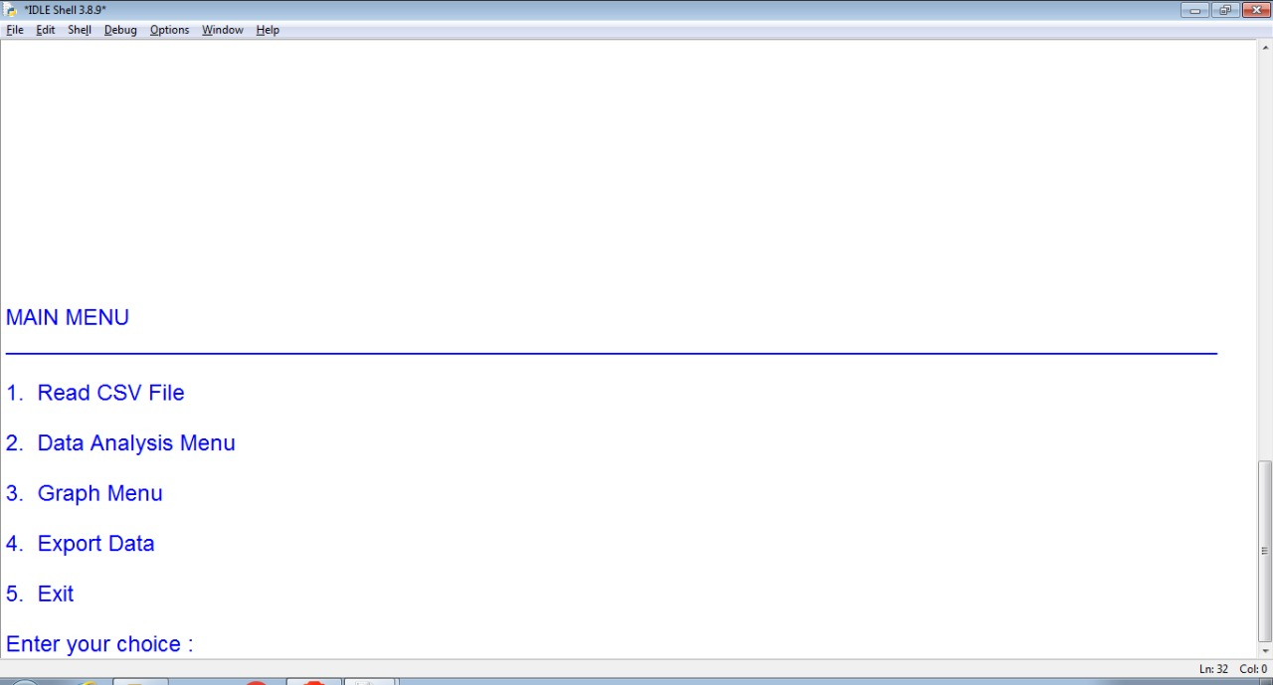

Fig.2: Read CSV File.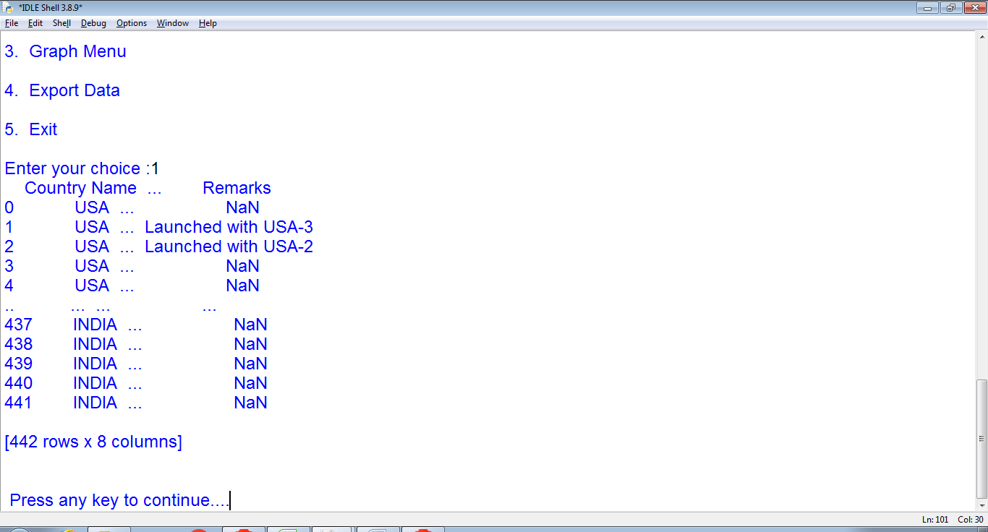

Fig.3: Data Analysis Menu.

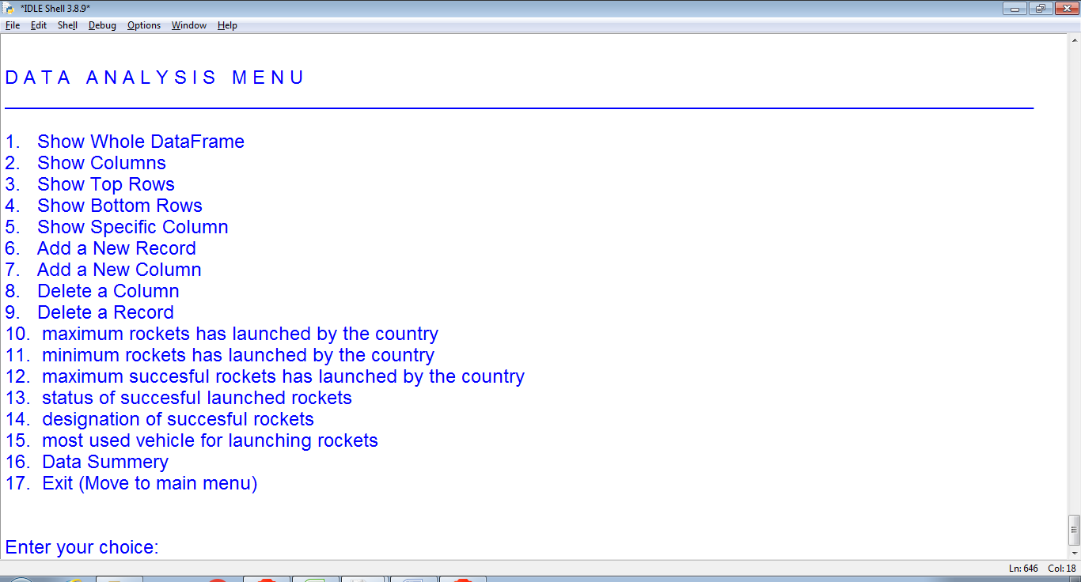
Fig.4: Show Whole Data Frame.

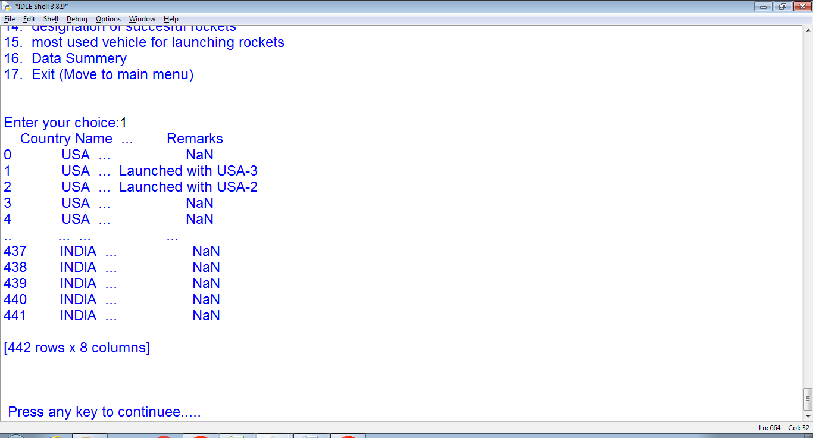

Fig.5: Show Columns.

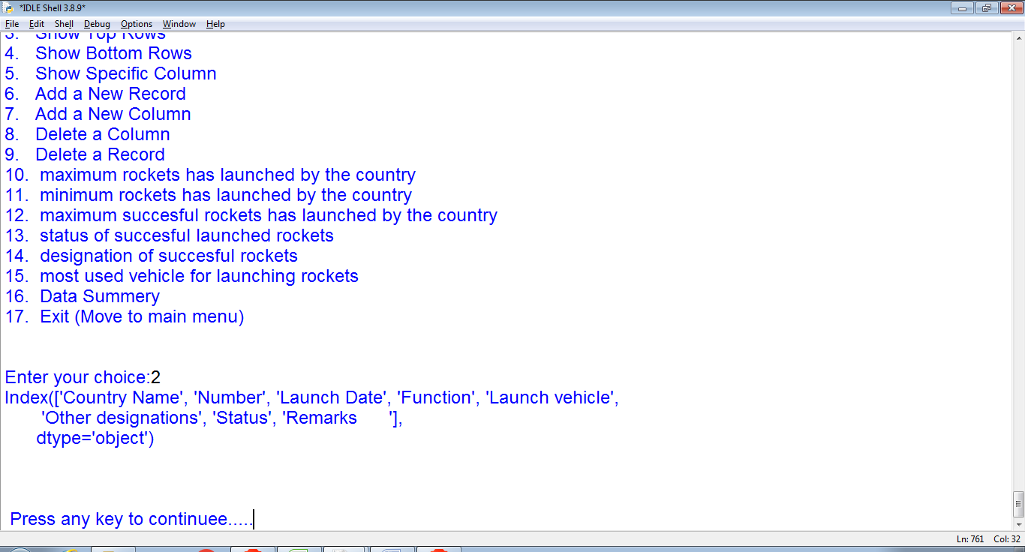
Fig.6: Show Top Rows.

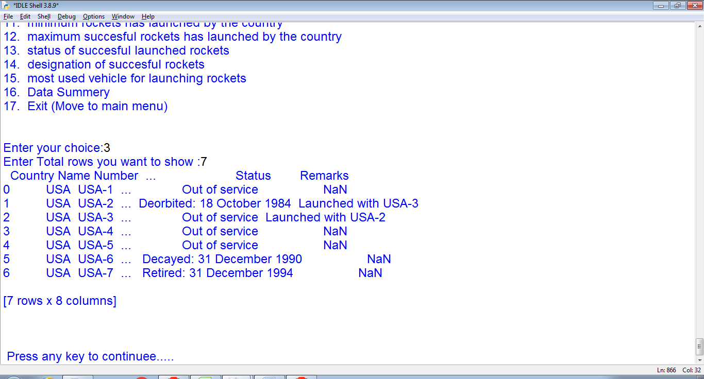

Fig.7: Show Bottom Rows.

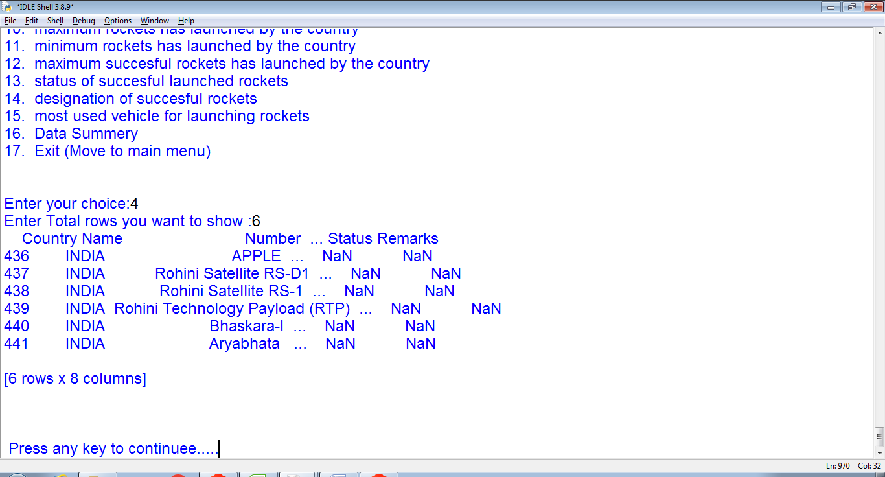
Fig. 8:Show Specific Cloumn.

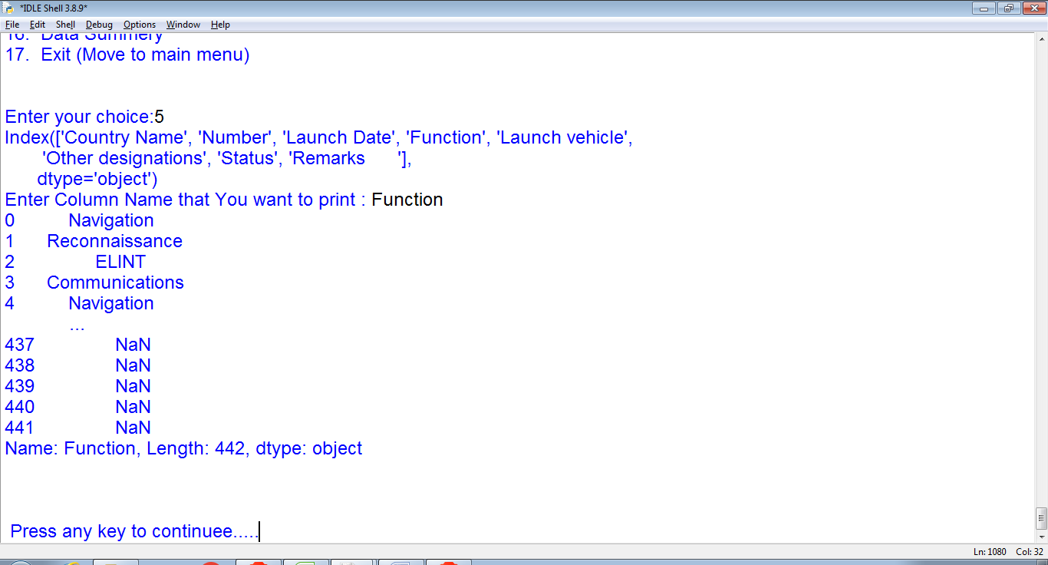

Fig.9 : Maximum Rockets Has Launched By The Country.
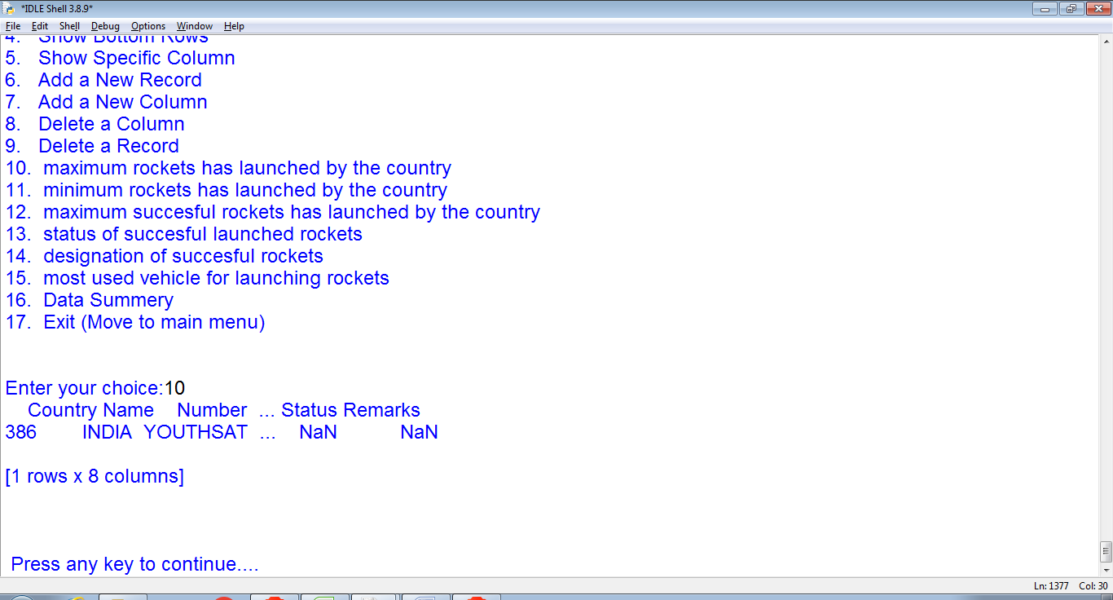

Fig. 10: Minimum Rockets Has Launched By the Country.
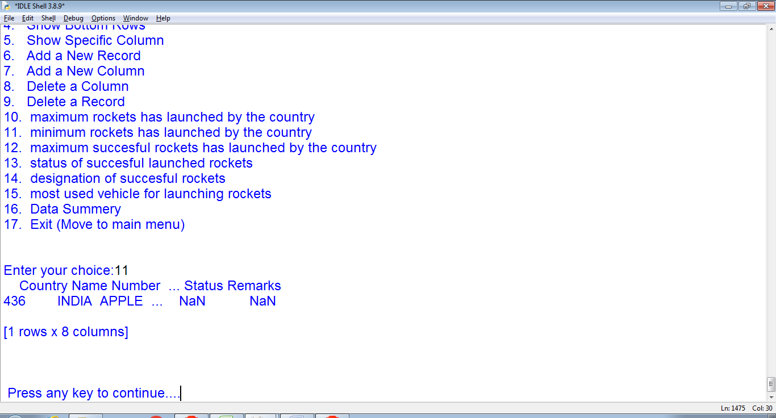
Fig. 11: Maximum Successful Rockets Has Launched By The Country.
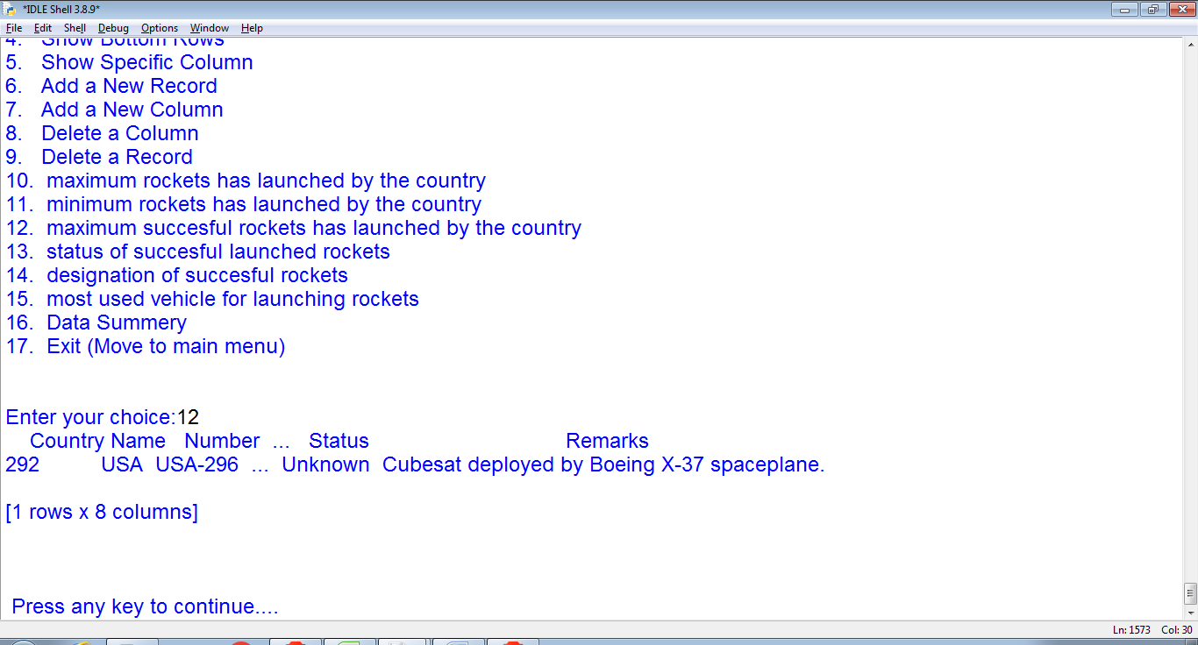

Fig. 12: Status Of Successful Launched Rockets.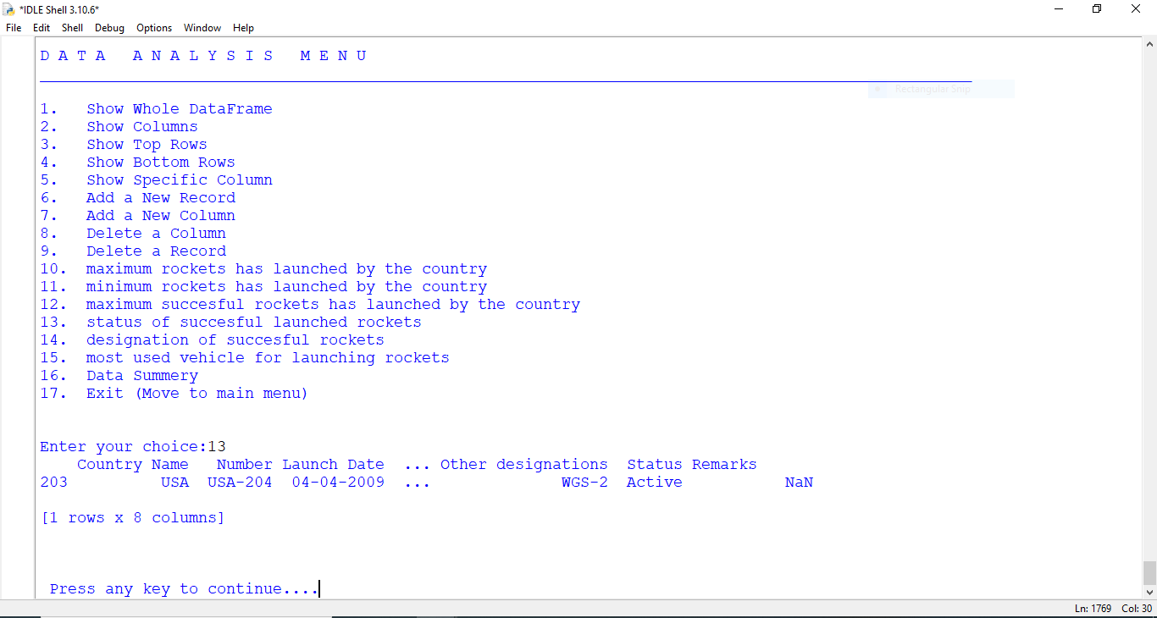
Fig. 13: Designation Of Successful Rockets.
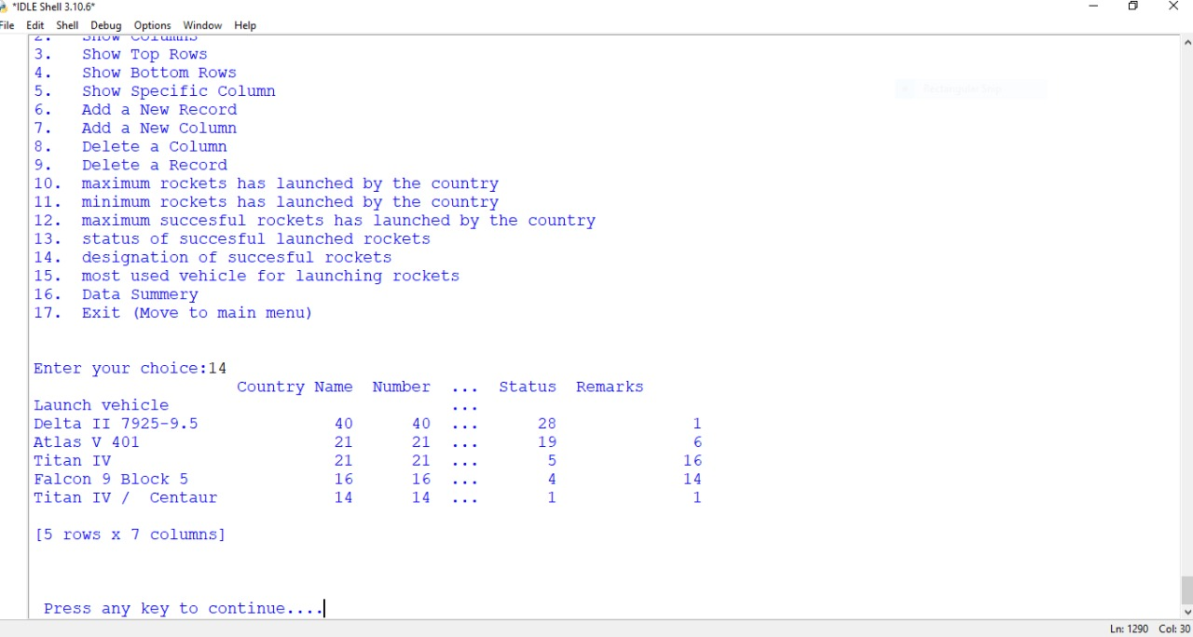

Fig. 14:Most Used Vehicle For Launching Rockets.

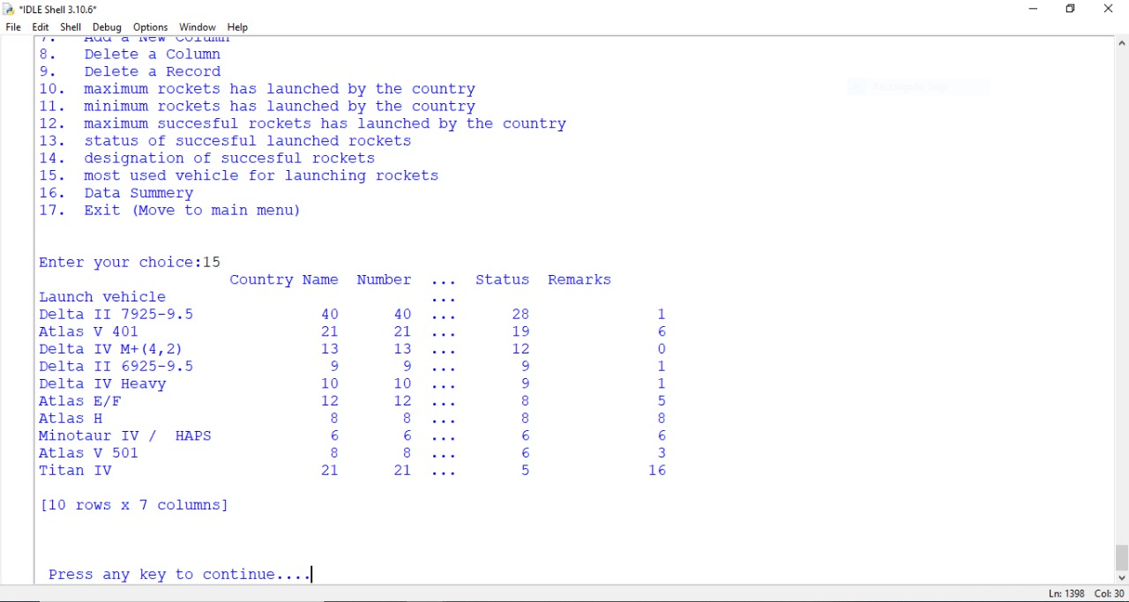
Fig. 15:Data Summery.
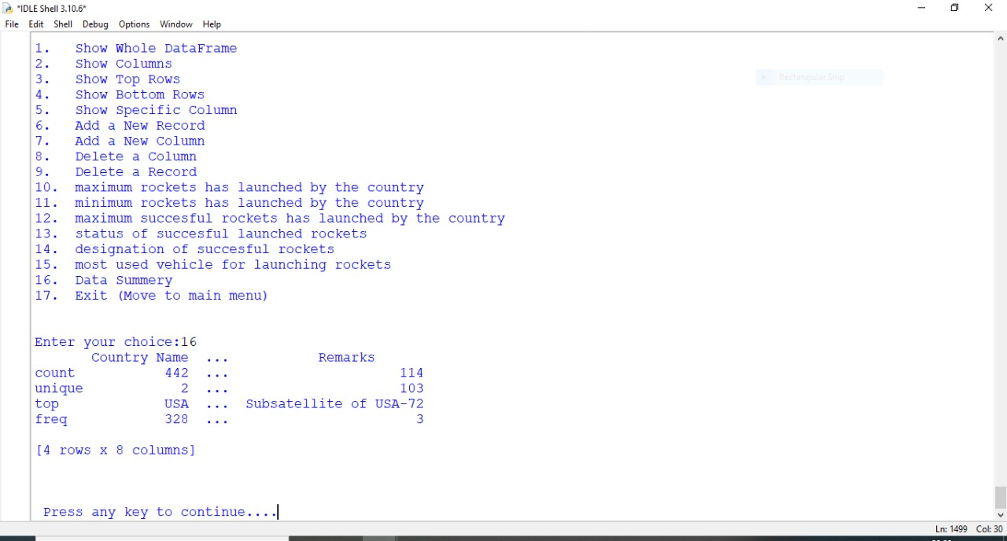

CHAPTER- 8
Conclusion

Conclusion

We have developed the project with following analysis:

- Data Analysis Menu:

- maximum rockets has launched by the country
- minimum rockets has launched by the country
- maximum successful rockets has launched by the country
- status of successful launched rockets
- designation of successful rockets
- most used vehicle for launching rockets
- Data Summery

Due to lack of time we propose to do the following analysis in the future:

- Graph Menu
- Export Data

CHAPTER- 9
Bibliography

Bibliography:

- Informatics practices class XI ( By: NCERT )
- Informatics practices class XII ( By: NCERT )
- Informatics practices class XI ( By: SUMITA ARORA )
- Informatics practices class XII ( By: SUMITA ARORA )
- Class Notes
- https://www.google.com/
- https://en.m.wikipedia.org/wiki/List_of_Indian_satellites
- https://en.m.wikipedia.org/wiki/List_of_USA_satellites
- https://en.wikipedia.org/wiki/Rocket

